Instructions to Access Codex through Your ChatGPT Edu Account
Overview
Step: Download Codex
Step: Set up Codex
Step: Build a test app
Step: Run a test app
Step: Revise a test app

Step: Download Codex
Action: Ensure that you log in to your ChatGPT Edu account using your university email. Follow the instructions here to request for access.
Action: Go to Codex Homepage & download the MacOS app or Windows App
Action: Log in to Codex through your university email
Action: Go to your Documents folder and create a folder called “code” or “Codex”
- Note: Every time you want to try a new Codex project, create a new folder inside of “code” - it’ll be easier for you to find later to keep all your code in one place

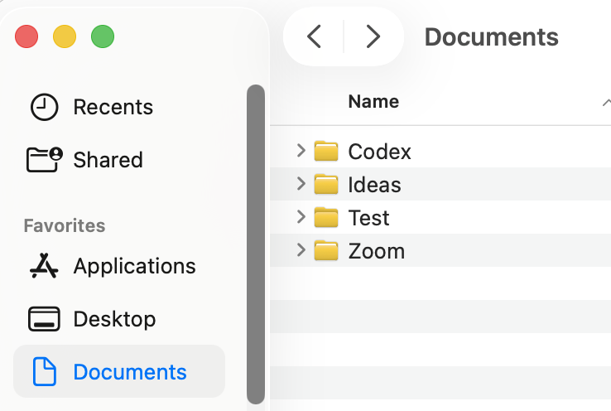

Step: Set up Codex
Action: Create a folder in your Documents called “test”
Action: Open Codex app, click on the dropdown, “Add New Project”, and select “test”

Milestone unlocked: you just set up your Codex environment, yay!

Step: Build a test app
Action: Build a classic Snake game in this repo

- Note: There’s 3 places to check out its handywork:
  - 1. The Codex app itself will be running and you can see it there
  - 2. In the top right corner it’ll show you logs of changes it’s made (for now it’ll only be additions, but as you make revisions, there will be subtractions and additions to the code)
  - 3. You can go back to the test folder in documents and you’ll see new files update!
- Note: There will be times Codex asks you for permission to run something on your computer (e.g. you’ve already given it permission to write code files, but it will explicitly ask you again before it downloads a code library from the web that it needs to complete something)

Milestone unlocked: you just created your first Codex app, yay!

Step: Run a test app
Action: Once it’s done running, test out whatever app it just built; usually, that requires reading the instructions that Codex gave you, e.g. “you need to run XYZ command in your terminal and then go to XYZ website in your browser”

Note: if Codex gives you terminal commands to run, you can usually just ask Codex to execute them on your behalf – “I don't know how to run anything on my local. Run any terminal commands for me and then tell me how to access the app”
- If for some reason Codex can’t, ask Codex “write all of the terminal commands in 1 command for me to run”, then open up the Terminal app on your laptop and copy-paste it
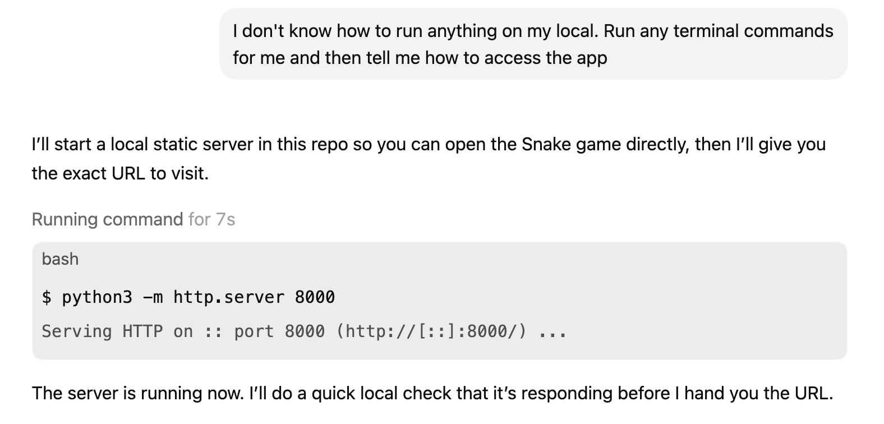
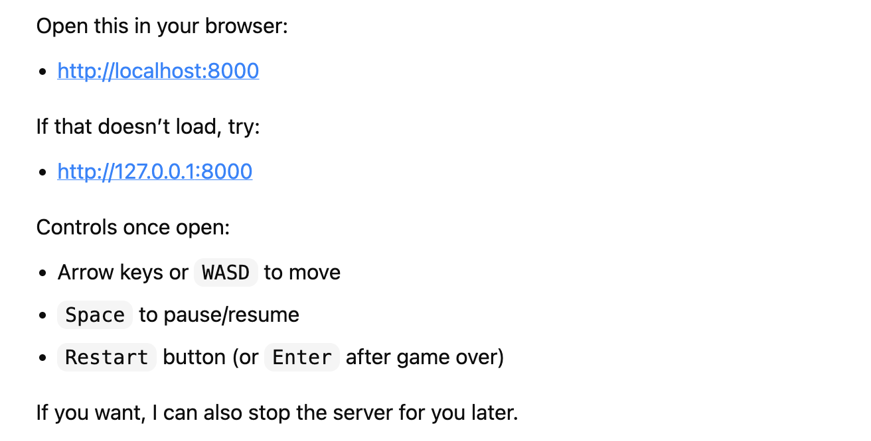

Note: if Codex gives you a website to go to (e.g. “http://localhost:8000/”), then just copy the URL it gave you and copy it into your web browser after the terminal commands have been run; the terminal commands start the app, and the web browser is how you access that app

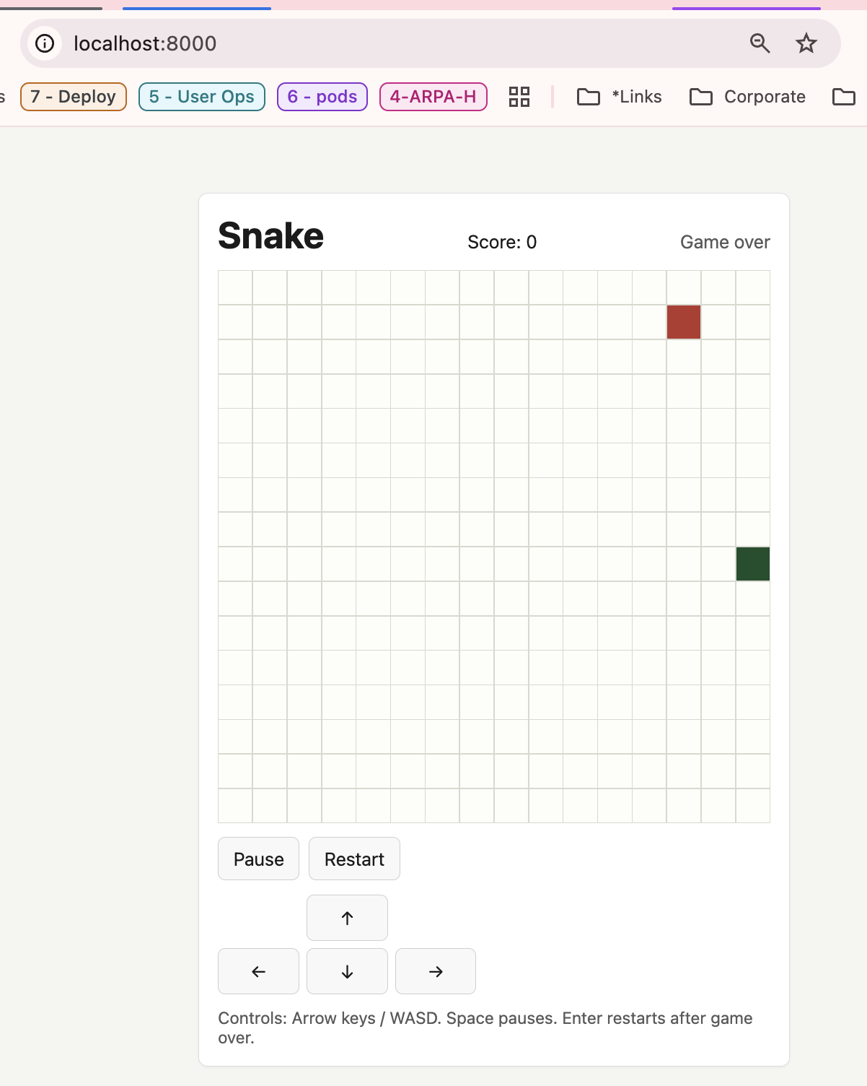

Milestone unlocked: you just ran your first Codex app, yay!

Step: Revise a test app
Action: Write another line in Codex to update the app in some way; e.g. in the snake app, ask it to change the background color of the game every time the snake gets the apple; then re-run the app
- Note: once it’s done, you should be able to reload the page in your browser should see additions and revisions to the code

Milestone unlocked: you just revised your first Codex app, yay!

